Surface Ozone Prediction
Using Machine Learning and Atmospheric Chemistry

Data Analysis, Model Development, and Evaluation Report
ASD390 Project
Sindhush Jayendra

1. Project Overview
This report documents the complete development pipeline for a surface ozone prediction system trained on five years of continuous ambient air quality monitoring data. The work covers exploratory data analysis, feature engineering grounded in atmospheric chemistry, model training and validation, SHAP-based interpretability analysis, and a comparative study of gradient boosting versus deep learning approaches.
The target variable throughout this study is near-surface ozone concentration, measured in micrograms per cubic metre. Ozone is a secondary pollutant formed through photochemical reactions between nitrogen oxides and volatile organic compounds under sunlight. Its prediction is non-trivial because it involves nonlinear chemistry, strong temporal memory, and regime-dependent behavior.

2. Dataset and Preprocessing

2.1 Data Source
Daily averaged pollutant measurements were collected from a single Central Pollution Control Board (CPCB) CAAQMS monitoring site over a five-year period from January 2020 through December 2024. The raw data was provided as five separate yearly CSV files, each covering one calendar year at daily resolution.
After merging and cleaning, the final dataset contains 1826 usable daily observations. The one missing observation at the start corresponds to the first row being dropped when lag features are constructed. The monitored variables cover ten key atmospheric species:

Pollutant | Unit | Role
PM2.5 | µg/m³ | Particulate matter (fine)
PM10 | µg/m³ | Particulate matter (coarse)
NO | µg/m³ | Nitric oxide (primary)
NO2 | µg/m³ | Nitrogen dioxide (primary/secondary)
NOx | ppb | Total nitrogen oxides
NH3 | µg/m³ | Ammonia
SO2 | µg/m³ | Sulfur dioxide
CO | mg/m³ | Carbon monoxide
Ozone | µg/m³ | Target variable (secondary)
Benzene | µg/m³ | VOC proxy

2.2 Timestamp Normalization
A technical issue was identified in the raw dataset: the first 1095 rows stored timestamps in the format YYYY-MM-DD HH:MM:SS while the remaining rows used YYYY-MM-DD. This inconsistency was resolved using pandas mixed-format datetime parsing, followed by normalization to remove the time component. All rows were then set to a DatetimeIndex and sorted chronologically to enforce a continuous daily time series.

2.3 Missing Value Handling
Missing values were imputed using time-based linear interpolation, which estimates missing concentration values by assuming smooth evolution between observed neighbors. For any remaining gaps at the boundaries of the dataset, forward and backward filling was applied as a fallback. After imputation, the dataset contained no missing values.
The justification for this approach is that atmospheric pollutant concentrations change gradually over short time windows in the absence of sudden emission events. The interpolation formula applied is:
C(t) = C(t1) + [(t - t1) / (t2 - t1)] * [C(t2) - C(t1)]
where C(t) is the estimated concentration at the missing time t, and t1 and t2 are the surrounding observed time points.

3. Exploratory Data Analysis

3.1 Photochemical Equilibrium
The fundamental reactions governing near-surface ozone involve the conversion of nitrogen dioxide under ultraviolet radiation and the subsequent reaction with molecular oxygen to form ozone. Nitric oxide then reacts with ozone to reform nitrogen dioxide, creating a cyclic photostationary equilibrium. The Leighton ratio, defined as the product of NO and O3 divided by NO2, provides a diagnostic for whether the observed chemistry follows this equilibrium or deviates due to additional reaction pathways such as VOC-driven peroxy radical chemistry.
The computed Leighton ratio in this dataset fluctuates between approximately 5 and over 200, indicating frequent deviations from simple equilibrium. These deviations confirm that VOC oxidation is actively perturbing the NOx-O3 system, which justifies the inclusion of this ratio as a machine learning feature.

3.2 VOC-NOx Regime Analysis
Using benzene concentration as a proxy for total volatile organic compound emissions, the VOC-to-NOx ratio was calculated to determine whether ozone formation is primarily limited by VOC availability or NOx availability. Most observations fall in the VOC-limited regime, which is consistent with large urban centers where vehicular NOx emissions are abundant. This finding implies that reducing VOC emissions would be more effective for ozone control than reducing NOx alone.

3.3 Distribution Characteristics
All primary pollutants exhibit right-skewed distributions with heavy tails. PM2.5 has a mean of approximately 109 µg/m³ with maximum values exceeding 400 µg/m³. NOx concentrations also display substantial variability, reflecting traffic emission dynamics. Ozone concentrations, being a secondary species constrained by photochemical equilibrium, show a more symmetric distribution with a mean near 25 µg/m³ and a maximum near 100 µg/m³.
These non-Gaussian distributions are important because they favor tree-based machine learning models over linear regression approaches, as tree models can capture nonlinear and asymmetric relationships without requiring distributional assumptions.

4. Feature Engineering

4.1 Physics-Derived Features
Two chemistry-based ratio features were constructed from raw pollutant measurements to encode domain knowledge directly into the feature space.

Leighton Ratio
Defined as (NO * O3) / (NO2 + 1), this ratio captures the degree to which the atmosphere deviates from photochemical equilibrium. The small constant in the denominator prevents division-by-zero conditions during low NO2 periods.
VOC-NOx Ratio
Defined as Benzene / (NOx + 1), this ratio encodes the atmospheric chemical regime. Higher values indicate NOx-limited conditions while lower values indicate VOC-limited conditions. This feature directly captures the regime-switching behavior observed in the data.

4.2 Temporal Features
Lag features were introduced to give the model access to past system states. The one-day lagged ozone value (O3_lag1) and the one-day lagged NOx value (NOx_lag1) were computed using pandas shift operations. These features enable the model to capture short-term temporal memory without requiring sequence modeling.
Calendar features were added to encode seasonality: month of year and day of year. These allow the model to account for seasonal patterns in photochemistry driven by solar radiation cycles.

4.3 Volatility and Interaction Features
Several additional features were added based on residual analysis of the baseline model:
- O3_volatility: rolling 3-day standard deviation of ozone, constructed using a lag-shifted window to avoid target leakage
- NOx_change: first difference of NOx concentration to capture sudden emission events
- NO2_O3_interaction: product of NO2 and ozone concentrations, encoding the nonlinear cross-term in the photochemical reaction chain
- high_NOx: binary flag for observations exceeding the 75th percentile of NOx, encoding pollution regime

4.4 Data Leakage Investigation
An initial version of the feature set included a 3-day rolling mean of ozone computed as the average of O3(t-2), O3(t-1), and O3(t), which inadvertently included the current observation in the window. This resulted in the feature receiving 77.8% of total feature importance and R2 jumping to 0.90. After the error was identified, the window was corrected to O3(t-3) through O3(t-1) using a shift-then-roll operation. The corrected feature still increased in importance slightly but at a reasonable level.
Subsequently, ablation testing showed that removing this rolling mean entirely produced slightly better performance than keeping the corrected version, suggesting the signal it provided was already captured by O3_lag1 and O3_volatility. The feature was dropped from the final model.

5. XGBoost Baseline Model

5.1 Model Selection Rationale
XGBoost was selected as the primary model for the following reasons: the dataset is tabular and relatively small (~1800 rows), the pollutant distributions are non-Gaussian and heavily skewed, the relationships between features and target are nonlinear and regime-dependent, and tree-based models require no feature scaling. These characteristics make gradient boosting a strong fit compared to linear models or unscaled neural networks.

5.2 Train-Test Split Strategy
To prevent data leakage in time-series data, a strict chronological split was applied. The first 80% of observations (approximately 1459 rows) form the training set, and the remaining 20% (approximately 365 rows) form the test set. Random splitting was not used because it would allow future values to appear in the training set.

5.3 Hyperparameter Configuration

Parameter | Value | Purpose
n_estimators | 800 | More trees for stable learning
max_depth | 5 | Limits tree complexity to reduce overfitting
learning_rate | 0.03 | Slower shrinkage for better generalization
subsample | 0.9 | Row sampling adds randomness
colsample_bytree | 0.9 | Feature sampling per tree
gamma | 0.1 | Minimum split gain threshold
reg_alpha | 0.1 | L1 regularization
reg_lambda | 1.0 | L2 regularization

5.4 Prediction Performance
The XGBoost model achieved the following results on the held-out test set:

Metric | Value
Mean Absolute Error (MAE) | 2.997 µg/m³
R-squared (R2) | 0.890
CV MAE (5-fold) | 3.344 µg/m³
CV R2 (5-fold) | 0.840

The small gap between test R2 (0.890) and cross-validation R2 (0.840) confirms that the model generalizes well and is not overfitting to the test period.

5.5 Prediction Plot

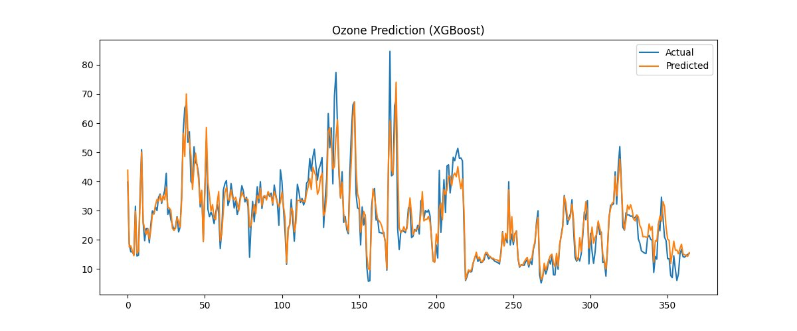
Figure 1. Actual vs Predicted ozone concentration (XGBoost). The model tracks the overall trend and captures medium-amplitude variations well. Some underestimation occurs at sharp peaks.

5.6 Remaining Weaknesses
The model consistently underestimates ozone during sharp peak events. The top residual errors range from approximately 22 to 24 µg/m³. These occur at days where ozone concentration rises rapidly, likely driven by stagnant meteorological conditions or sudden VOC-driven photochemical episodes. XGBoost smooths these extreme events because it learns from the full training distribution, and extreme events are underrepresented.

6. Time-Series Cross Validation

6.1 Motivation
A single train-test split provides only one estimate of model performance, which may be sensitive to the choice of split point. TimeSeriesSplit evaluates the model across multiple rolling windows, each training on past data and predicting a future held-out segment. This gives a more robust picture of how the model generalizes.

6.2 Fold-by-Fold Results

Fold | MAE | R2
Fold 1 | 3.059 | 0.792
Fold 2 | 2.962 | 0.827
Fold 3 | 5.110 | 0.777
Fold 4 | 2.495 | 0.925
Fold 5 | 3.093 | 0.879
Mean (CV) | 3.344 | 0.840

Fold 3 shows noticeably higher MAE and lower R2 compared to other folds. This corresponds to a segment of the dataset likely covering a period with different pollutant dynamics, possibly a seasonal transition or an anomalous emission episode. The performance recovers in subsequent folds, suggesting this is a data-driven effect rather than a modeling deficiency.
The overall CV R2 of 0.840 confirms that the model is robust across different time windows and not specifically tuned to the test period.

7. Feature Importance Analysis

7.1 XGBoost Intrinsic Importance

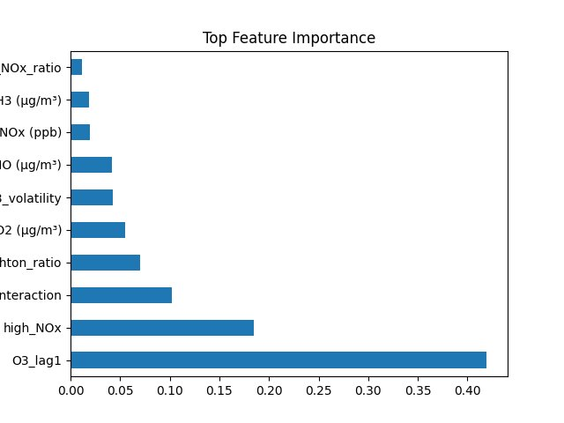
Figure 2. Top feature importances from XGBoost based on split gain frequency.

Feature | Importance | Interpretation
O3_lag1 | 0.420 | Strong temporal persistence of ozone
high_NOx | 0.185 | Pollution regime indicator
NO2_O3_interaction | 0.102 | Nonlinear photochemical cross-term
Leighton_ratio | 0.071 | Photostationary equilibrium diagnostic
NO2 (µg/m³) | 0.055 | Primary ozone precursor
O3_volatility | 0.043 | Short-term variability capture
NO (µg/m³) | 0.041 | NOx titration of ozone
NOx (ppb) | 0.019 | Total nitrogen oxide load

7.2 Interpretation
The dominant feature is O3_lag1, indicating that ozone on any given day is strongly predicted by ozone on the previous day. This makes physical sense: ozone can persist in the lower atmosphere for one to several days depending on NOx availability and meteorological conditions.
The second most important feature is high_NOx, the binary regime flag. This shows that whether the atmosphere is in a high-NOx state significantly changes the ozone prediction, consistent with the NOx-limited and VOC-limited regime behavior identified in the EDA.
NO2_O3_interaction and Leighton_ratio together confirm that the model is learning chemistry-based relationships rather than purely statistical correlations. These features encode the nonlinear coupling between the ozone and nitrogen oxide species that forms the basis of tropospheric ozone chemistry.

8. SHAP Explainability Analysis

8.1 Overview
SHAP (SHapley Additive exPlanations) values decompose each model prediction into additive contributions from individual features. Unlike standard feature importance metrics which only show average contribution magnitude, SHAP shows both the direction and magnitude of each feature's influence for each individual prediction. This makes it possible to verify that the model is making predictions for the right reasons.

8.2 Global SHAP Summary

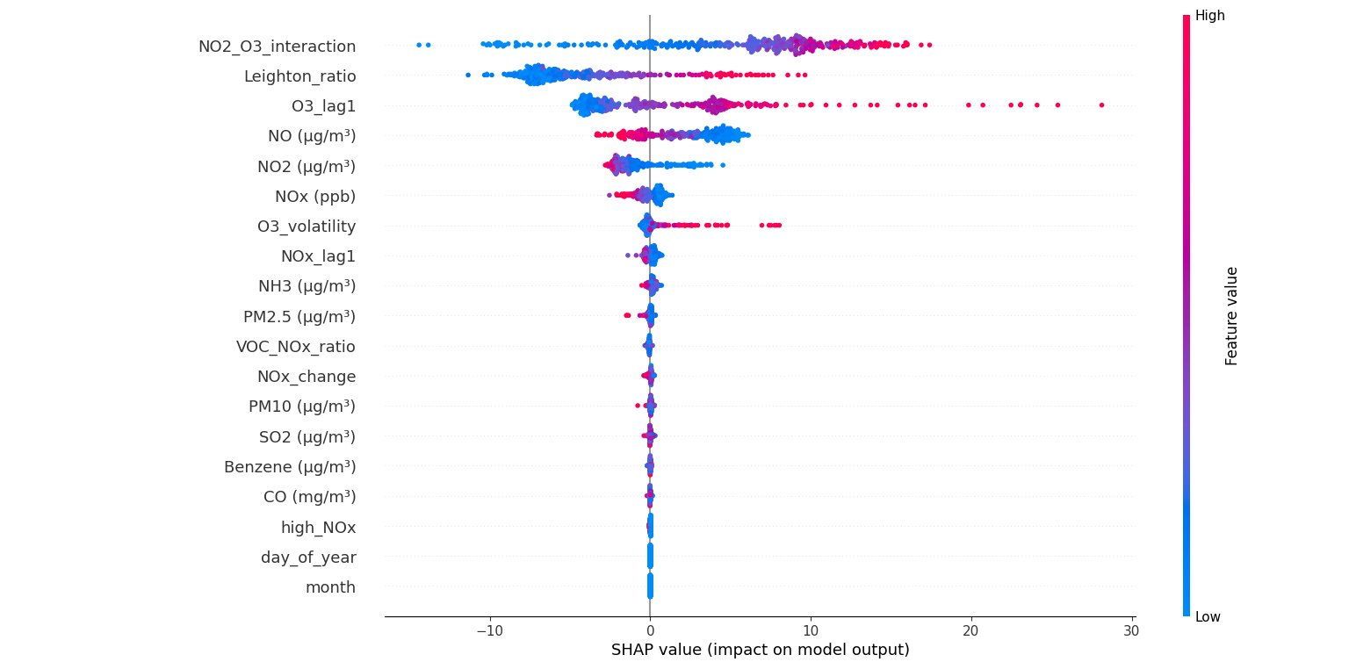
Figure 3. SHAP summary plot showing feature impact across all test observations. Red indicates high feature values, blue indicates low values.

The SHAP summary confirms several important findings. NO2_O3_interaction and Leighton_ratio are the top two features by SHAP magnitude, both dominating over O3_lag1 in terms of total predictive range. This means that while the lag feature provides a strong baseline prediction, the chemistry features are responsible for the directional adjustments that capture actual variation.
NO has a consistently negative SHAP impact when concentrations are high (red points pushed left). This aligns with the NOx titration effect: high NO concentrations destroy ozone, reducing predicted values. Conversely, low NO concentrations (blue) are associated with ozone accumulation.
The calendar features (month and day_of_year) appear at the bottom with near-zero SHAP values. This indicates that seasonality is already encoded implicitly through the pollutant concentration patterns and the chemistry ratio features, making explicit temporal encoding redundant.

8.3 Leighton Ratio Dependence Plot

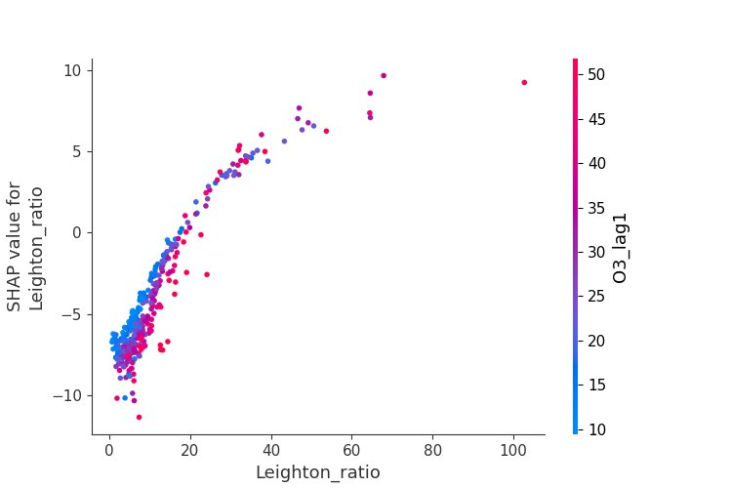
Figure 4. SHAP dependence plot for Leighton_ratio, colored by O3_lag1. Shows nonlinear response of ozone to photostationary deviations.

The dependence plot for Leighton_ratio shows a clear nonlinear relationship. At low ratio values (below 10), SHAP values are strongly negative, meaning the model reduces ozone predictions when the atmosphere is far from the NOx-O3 equilibrium in the titration direction. As the ratio increases, SHAP values rise and then plateau, indicating diminishing returns. The color overlay (O3_lag1) shows that high lagged ozone days (pink and red) tend to cluster at higher ratio values, which is consistent: periods of elevated ozone sustain high Leighton ratios.

8.4 NO2-O3 Interaction Dependence Plot

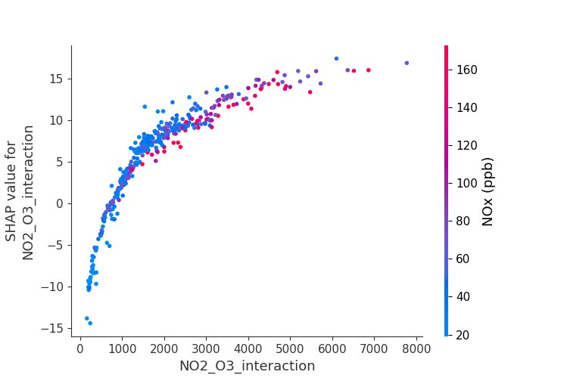
Figure 5. SHAP dependence plot for NO2_O3_interaction, colored by NOx. The log-linear curve reveals diminishing returns in ozone sensitivity to this interaction term.

The NO2_O3_interaction plot shows a logarithmic shape: SHAP values increase sharply at low interaction values and level off above approximately 3000. The coloring by NOx concentration shows that high-NOx days (red) cluster at high interaction values with moderate SHAP contributions. This reflects the saturation behavior of ozone formation chemistry when both NO2 and precursor concentrations are abundant.
Together, the SHAP analysis confirms that the model has internalized chemically meaningful relationships. The predictions are not driven by spurious statistical correlations but by the actual reaction pathways that govern near-surface ozone formation.

9. LSTM Comparison and Stacking

9.1 LSTM Architecture and Setup
A Long Short-Term Memory network was implemented using PyTorch to investigate whether sequential modeling adds value beyond the lag-feature approach used in XGBoost. The LSTM receives sequences of 5 consecutive daily observations and outputs a single ozone prediction for the following day. All features were normalized using StandardScaler before training.
Architecture: 2-layer LSTM with hidden dimension 64, followed by a linear output layer. Training used Adam optimizer with learning rate 0.001 over 50 epochs with batch-level gradient updates.

9.2 LSTM Results

Model | MAE | R2
XGBoost | 2.997 | 0.890
LSTM | 8.146 | 0.350
Stacked (meta-learned) | 2.992 | 0.899

9.3 Why LSTM Underperformed
LSTM performed substantially worse than XGBoost for several interconnected reasons:
- The dataset contains only about 1800 observations, which is small for recurrent neural networks that typically require thousands of sequences to learn stable temporal patterns
- The feature engineering pipeline already encoded temporal information explicitly through O3_lag1, NOx_lag1, and O3_volatility. LSTM was not discovering new temporal signal; it was re-learning what was already given to XGBoost as a precomputed feature
- Without meteorological variables (temperature, solar radiation, wind speed), the LSTM had no additional contextual signal to exploit that was not already present in the lag features

9.4 Stacked Model
A meta-learner was trained using LinearRegression to find the optimal linear combination of XGBoost and LSTM predictions. The learned weights were:
- XGBoost weight: 1.107
- LSTM weight: -0.009
- Bias: -3.072

The near-zero LSTM weight confirms that the stacking model learned to rely almost entirely on XGBoost. The slight negative LSTM weight and non-zero bias act as small correction terms. The final stacked R2 of 0.899 is marginally better than XGBoost alone (0.890), but the practical improvement is minimal.
This result supports the conclusion that gradient boosting with physics-informed feature engineering is the dominant modeling approach for this problem given the current dataset size and feature set.

10. Final Model Summary

10.1 Finalized Feature Set

Feature | Type | Origin
PM2.5 (µg/m³) | Raw | CPCB measurement
PM10 (µg/m³) | Raw | CPCB measurement
NO (µg/m³) | Raw | CPCB measurement
NO2 (µg/m³) | Raw | CPCB measurement
NOx (ppb) | Raw | CPCB measurement
NH3 (µg/m³) | Raw | CPCB measurement
SO2 (µg/m³) | Raw | CPCB measurement
CO (mg/m³) | Raw | CPCB measurement
Benzene (µg/m³) | Raw | CPCB measurement
Leighton_ratio | Engineered | NO * O3 / (NO2 + 1)
VOC_NOx_ratio | Engineered | Benzene / (NOx + 1)
O3_lag1 | Temporal | Ozone at t-1
NOx_lag1 | Temporal | NOx at t-1
O3_volatility | Temporal | Rolling 3-day std (lagged)
NOx_change | Temporal | First difference of NOx
NO2_O3_interaction | Interaction | NO2 * O3
high_NOx | Regime | Binary: NOx > 75th percentile
month | Calendar | Month of year
day_of_year | Calendar | Day of year

10.2 Performance Comparison Across Development Stages

Stage | MAE | R2 | Key Change
XGBoost (no tuning) | 5.837 | 0.644 | Baseline with raw features
XGBoost + CV + tuning | 5.025 | 0.718 | Added time features, tuned params
XGBoost + phase 7 features | 2.998 | 0.890 | Interaction, regime, volatility features
Stacked ensemble | 2.992 | 0.899 | Meta-learned XGB + LSTM combination

10.3 Conclusions
The final XGBoost model achieves an MAE of approximately 3.0 µg/m³ and an R2 of 0.890 on the held-out test year. Cross-validation confirms this generalizes to a CV R2 of 0.840 across multiple time windows. SHAP analysis verifies that the model is learning atmospheric chemistry relationships rather than spurious correlations.
The main remaining limitation is underestimation of extreme ozone peaks. These events are rare in the training data and likely driven by meteorological factors (temperature, wind stagnation, photolysis rates) that are not measured at CPCB stations. Including meteorological predictors would be the single most impactful next step for improving prediction at extremes.
The LSTM comparison demonstrated that for this dataset, physics-informed feature engineering provides more value than sequence modeling. The lag features and chemistry ratios encode the temporal and chemical dynamics that LSTM would otherwise need to learn from raw sequences, leaving minimal additional signal for the recurrent model to capture.

11. Next Steps

11.1 Physics-Informed Neural Network
The next planned modeling component is a Physics-Informed Neural Network (PINN) that explicitly enforces the NOx-O3 photostationary balance as a soft constraint during training. The total loss function becomes:
L_total = L_data + lambda * L_physics
where L_data is the mean squared prediction error and L_physics penalizes deviations from the Leighton equilibrium relationship. The physics weight lambda controls how strongly the constraint is enforced.

11.2 Meteorological Feature Integration
Temperature, solar radiation, boundary layer height, and wind speed are the most important missing predictors for ozone. These govern photolysis rates, vertical mixing, and ozone precursor residence times. Integrating ERA5 reanalysis data or ground-level meteorological station data would substantially improve prediction at extreme events.

11.3 Uncertainty Quantification
Adding prediction intervals or quantile regression would allow the model to report not just a point estimate but also a confidence range. This is particularly important for air quality forecasting applications where regulators need to know the probability that ozone will exceed health-based thresholds.

ASD390 Surface Ozone Prediction Project | Sindhush Jayendra

